Fraternal greetings everyone

As we are in the midst of a special election cycle for the positions of R.K.I.F.M.C.
Vice President and Region 2 Director, the R2D vacancy had a sole qualified candidate.
Randy Smith, an Active Member of R.K.M.C. Ontario Chapter 1 has been declared, by the Nominations Committee, the new Region 2 Director.

Please join me as we welcome Randy to the International Board, as only the 5th
Region 2 Director in our 40-year international history.
Randy was sworn into office last evening (10-30-2023) on a scheduled IB Zoom Meeting.
We as a Board are looking forward to working side-by-side with him.
Again Randy, Congratulations and welcome.

On behalf of the International Board of Directors,
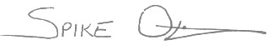
R. Spike Ostiguy
International President

